Abstract:

Abstracts

**Abstract - 1**

Given the increase in ﬂood events in recent years, accurate ﬂood risk assessment is an important component of ﬂood mitigation in urban areas. This research aims to develop updated and accurate ﬂood risk maps in the Don River Watershed within the Great Toronto Area (GTA). The risk maps use geographical information systems (GIS) and multi-criteria analysis along with the application of Analytical Hierarchy Process methods to deﬁne and quantify the optimal selection of weights for the criteria that contribute to ﬂood risk. The ﬂood hazard maps were generated for four scenarios, each with different criteria (S1, S2, S3, and S4). The base case scenario (S1) is the most accurate, since it takes into account the ﬂoodplain map developed by the Toronto and Region Conservation Authority. It also considers distance to streams (DS), height above nearest drainage (HAND), slope (S), and the Curve Number (CN). S2 only considers DS, HAND, and CN, whereas S3 considers effective precipitation (EP), DS, HAND, and S. Lastly, S4 considers total precipitation (TP), DS, HAND, S, and CN. In addition to the ﬂood hazard, the social and economic vulnerability was included to determine the total ﬂood vulnerability in the watershed under three scenarios; the ﬁrst one giving a higher importance to the social vulnerability, the second one giving equal importance to both social and economic vulnerability, and the third one giving more importance to the economic vulnerability. The results for each of the four ﬂood scenarios show that the ﬂood risk generated for S2 is the most similar to the base case (S1), followed by S3 and S4. The inclusion of social and economic vulnerability highlights the impacts of ﬂoods that are typically ignored in practice. It will allow watershed managers to make more informed decisions for ﬂood mitigation and protection. The most important outcome of this research is that by only using the digital elevation model, the census data, the streams, land use, and soil type layers, it is possible to obtain a reliable ﬂood risk map (S2) using a simpliﬁed method as compared to more complex ﬂood risk methods that use hydraulic and hydrological models to generate ﬂood hazard maps (as was the case for S1)

**Materials and Methods**

The study area for this research was selected as the shared area between the GTA and the DonRiver watershed, which corresponds to an area of 202.6 km2(Figure 1). Precipitation data from fourrain gauges (labeled HY008, HY016, HY021, and HY027) in Toronto were provided by the TRCA.The locations of the rain gauges are shown in Figure 1. The data showed that between 2009–2016,the months with the highest precipitation are typically from May to October, with an average rainfallof 82 mm/month, while the average rainfall from November to April is 29 mm/month (as illustratedin Figure 2). The Don River is one of the main watercourses that drains the GTA, running from OakRidges Moraine into Lake Ontario with a total length of about 100 km. It is composed of three mainbranches (East Don, West Don, and lower Don) and other two tributaries (Taylor/Massey Creek andGerman Mills Creek)

Figure 2.

Average monthly precipitation in Toronto (from 2009 to 2016) for each of the four rain gauges

(HY008, HY016, HY021, and HY027) used for this research.

The GTA, with a population of about 6.4 million people in 2016, is the most densely populated metropolitan area in Canada. Furthermore, Toronto has experienced one of the fastest periods of growth in the last decades compared to other large and high-income metropolitan areas in the world.

Since 1931, the population has increased 700% [24]. This rapid and sustained growth has made this region and watershed highly urbanized, with more than 75% of the area developed. Over the last 100 years, four signiﬁcant ﬂood events have occurred, and have signiﬁcantly affected the area with fatalities, considerable economical losses, and infrastructural damage.

Table 1summarizes some statistical information of these previous events, including the dates and intensity of the precipitation.

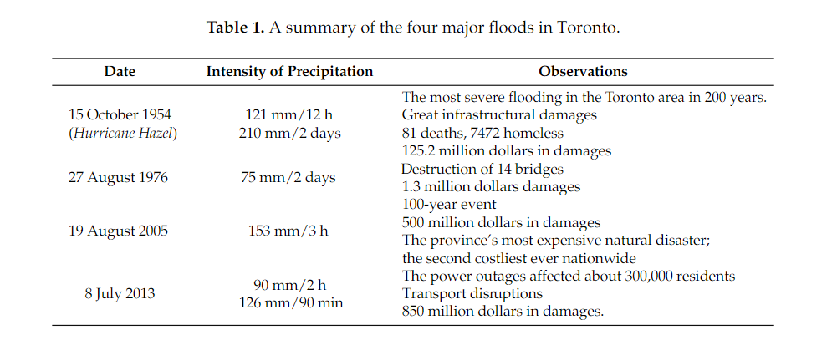

**Abstract-2**

In this paper we propose a multi-modal deep learning approach to detect floods in social media posts. Social media posts normally contain some metadata and/or visual information, therefore in order to detect the floods we use this information. The model is based on a Convolutional Neural Network which extracts the visual features and a bidirectional Long Short-Term Memory network to extract the semantic features from the textual metadata. We validate the method on images extracted from Flickr which contain both visual information and metadata and compare the results when using both, visual information only or metadata only. This work has been done in the context of the MediaEval Multimedia Satellite Task.

**Methodology**

In this section we will discuss the deep learning algorithm design for the task of flood evidence retrieval in social media posts. The problem will be approached under a probabilistic framework. As explained in Section 2, the posts contain an image and/or metadata. To extract rich visual information we apply the convolutional InceptionV3 network, using the pre-trained weights on ImageNet [2] and fine-tune the last inception model of the network. For the metadata we use a word embedding to represent the textual information in a continuous space and feed it to a bidirectional LSTM. The word embedding is initialized using Glove [9] vectors, which we fine-tune with our metadata. Finally, we concatenate the image and text features followed by a fully connected layer and a softmax classifier to give a final probability of the sample containing relevant information about a flood. In Figure 2 we show a sketch of the multimodal system, which can also be applied using only one of the modalities.

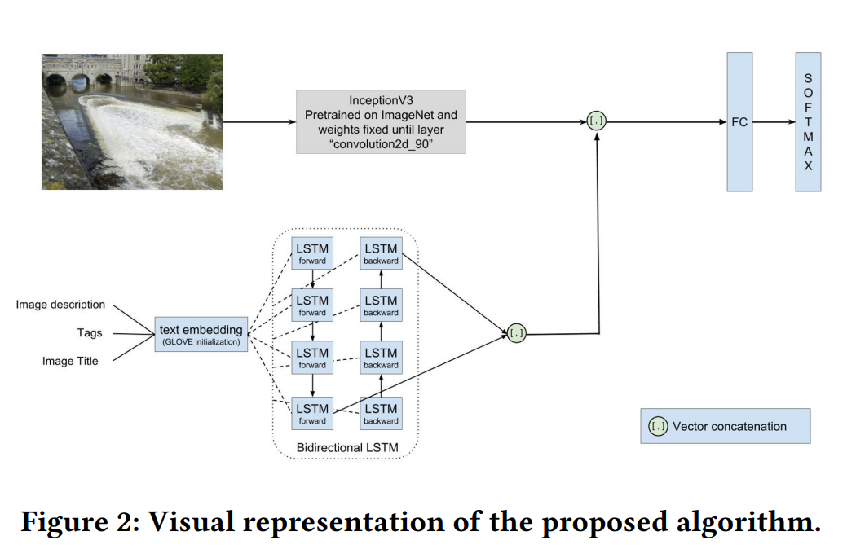

**Abstract-3**

In August 2018, the state of Kerala in India witnessed its worst flood that occurred in nearly a century, after the great flood of 99 that happened in 1924.About one-sixth of the total population was affected. In this paper, Geographic Infromation System(GIS) is used to map the recent flood and to analyse the impacts of the flood. This study helps in better understanding of the flood that occurred and can be used as a reference to set up flood management plans and to help the government and other agencies to improve decision making plans in order to re-allocate resources as to help the population in need

**Methodology**

1. Flood map

Flood maps will allow non-technical users to analyze what kind of facilities would be affected in flood hazard areas. A person can decide if his or her property will be at risk and he or she could identify safer locations [4]. For creating a Flood map, boundary map of the study area, Kalady has been collected from the Kalady Panchayat. This boundary was digitized based on Google Earth Pro. Surveys were carried out in all 17 wards of the Panchayat to collect latitude, longitude and approximate water levels. Latitude and longitude were collected using True Compass app and water levels were measured. These data are converted to excel sheets. Shape file of the study area is created in ArcGIS 10.3 software and all the surveyed points are added to the shape file of boundary using add data tool. Kriging tool available in the ArcGIS software is used to interpolate the points and thus create the flood map.

Flood maps will allow non-technical users to analyze what kind of facilities would be affected in flood hazard areas. A person can decide if his or her property will be at risk and he or she could identify safer locations [4]. For creating a Flood map, boundary map of the study area, Kalady has been collected from the Kalady Panchayat. This boundary was digitized based on Google Earth Pro. Surveys were carried out in all 17 wards of the Panchayat to collect latitude, longitude and approximate water levels. Latitude and longitude were collected using True Compass app and water levels were measured. These data are converted to excel sheets. Shape file of the study area is created in ArcGIS 10.3 software and all the surveyed points are added to the shape file of boundary using add data tool. Kriging tool available in the ArcGIS software is used to interpolate the points and thus create the flood map.

B.Flood impact map

Flood impact analysis can be study as changes likely to be occurring in environment characteristics that may results due to flood .For finding out the impact of flood on land use, a land use map have to be created in the software. For that a landsat image is downloaded and using the image classification tool in the software, a land use map have been created. The created flood map and land use map are overlayed in the software to obtain the flood impact map.Areas having water level more than 2.5m is clipped with the land use map

**Abstract-4**

The present study attempts to study the impact of floods in the Pune City in Maharashtra India. Data used in the present study was SOI toposheets, DEM, DGPS GCP for ground truth, discharge data from Water Resources Department Maharahstra Government. For analysis DEM was generated for the region of the city. DEM was processed for the fill; sink for the using Arc Hydro tool. From the analysis it was found that the probable discharge for the different years from the Khadakwasala Reservoir was found to be 283593.06 Cumecs. Using this data analysis for the submergence of the area was calculated. It was found that on the downstream of the reservoir Bhavani Peth and the Warje Karvenagar wards have highest extent of the floods in terms of the Population affected, while in the terms of the area affected Warje Karvenagar being the highest, followed by Shivane Village. From the work, it can be concluded that these area are more vulnerable for the flooding. Appropriate measures can be taken by the local municipal corporation (PMC) to reduce the extent of floods. Also in these areas real estate is more blooming. Care need to be taken to strictly enforce the laws to kerb the human settlements in these areas.

**Methodology**

Figure Show the methodology adopted for the present study. DEM data is processed that is raw DEM is Conditioned for the Fill and Sink. This is t he most commonly adopted method to avoid the errors in the DEM generated. After these operations the Flow direction is calculated using the data which will check the adjoining pixel values. Based on the slope values the flow direction was determined. In the next step Stream is identified and the streams are segmented. After all this preprocessing drainage line was finalized.

